

LET

’

S TAKE A CLOSER LOOK

AT THE FACTS

⇒

Missing school at an early age

can make it harder to perform

well in important subjects like

math and reading.

⇒

Missing school this year in-

creases the risk that you will

miss a lot of school next year,

too.

⇒

18

or more absences from

school can make it harder to

meet your educational goals.

⇒

Being ab-

sent a lot

during the

first month

of school

can lead to

more ab-

sences later

in the year.

**Why is Attendance**

**Important at your Age?**



→

Just like when you are absent,

coming to school late means

that you missed important class

time and those minutes add up!

→

Coming to school late a lot puts

students at risk for missing

schooldays, too.

→

If you come to school late a lot

it can make it harder to learn

and do well on tests.

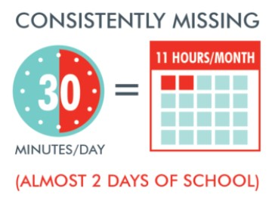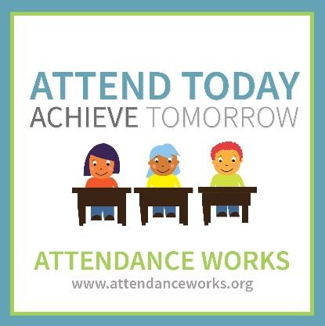

**What About Coming to**

**School Late?**

HOW WE CAN WORK T

O-

GETHER?



Come to school

**everyday**

.



Stay at home if you are sick and

try to bring a doctors note with

you when you come back to

school.



Think about ways you can im-

prove your nightly and morning

routines.



Reach out to Ms. Foreman if you

are concerned about your at-

tendance or you need help man-

aging your routine. We have

school resources that can

**help**

you!